Inverse perspective mapping procedure for timelapse camera
Loïc Van Audenhaege¹, Daniel O. B. Jones¹
¹National Oceanography Centre, Southampton, UK
Emails: loicva@noc.ac.uk, loic.vanaudenhaege@gmail.com
This document outlines the mathematical procedure used to correct time-lapse images and annotations for perspective, following a two-axes rotation procedure commonly used for inverse perspective mapping. The companion code is available on GitHub - LoicVA/Perspective-transformation-for-timelapse-imagery
Note that this script relies on a few assumptions:
- The seabed is flat (slope = 0°).
- The camera pan is null.
- The principal point is located in the centre of the image.
- The angle of vertical acceptance remains below the horizontal line (see Figure 1) to avoid an infinite propagation in the water column which cannot be resolved.
(1) Correction of angles of acceptance for water refraction
Angles of acceptance can be corrected for water refraction using the Snell’s law, especially when the camera is enclosed in an air dome.
(1)
$$n_{1}×sin\left(α_{air}\right)=n_{2}×\sin\left(α_{water}\right)$$
which becomes after readjustment,
(2)
$$α_{water}=\sin^{-1}\left(\frac{n_{1}}{n_{2}}×\sin\left(α_{air}\right)\right)$$
Given typical refractive indices – n₁ (air) = 1.00 and n₂ (seawater) = 1.33 – vertical and horizontal angles of acceptance can be adjusted using α_{air} provided by the manufacturer.
(2) Real-world correspondence of corner coordinates
Consider a camera mounted at heigh h above a flat seafloor, tilted at a known angle. The vertical (α_{v}) and horizontal (α_{h}) acceptance angles are given. Point P represents the principal point, where the optical axis intersects the image plane (Wakefield and Genin 1987).
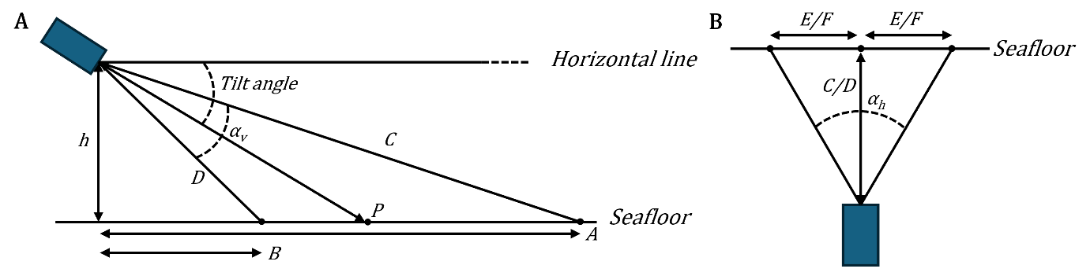
Figure 1. Diagram illustrating parameter positioning: (A) lateral view and (B) top-down view perpendicular to C/D, used to calculate upper/lower image corners, respectively.
From a lateral view (Supplementary Figure 2A):
The complementary angle to the tilt can be found by:
(3)
$$β=90°-Tilt$$
Using the known camera height vector (perpendicular to the seabed) and vertical acceptance angle, the tangent function allows us to estimate the horizontal distances from the camera to the upper image edge (A) and lower image edge (B).
These distances can be calculated using basic trigonometric identities.
(5)
(4)
$$A=\tan\left(β+\frac{α_{v}}{2}\right)×h$$
$$B=\tan\left(β-\frac{α_{v}}{2}\right)×h$$
The length of the upper and lower line of sight traveling from the principal point to the camera can be estimated using the cosine tangent function (Figure 1A):
(8)
(7)
$$C=\frac{h}{\cos\left(β+\frac{α_{v}}{2}\right)}$$
$$D=\frac{h}{\cos\left(β-\frac{α_{v}}{2}\right)}$$
From a top-down view (Figure 1B), maintaining the same tilt orientation, this view allows an estimation of the real-world distance E and F, between the middle of the upper and lower image edge, respectively and the image corner.
(10)
(9)
$$E=\tan\left(\frac{α_{h}}{2}\right)×C$$
$$F=\tan\left(\frac{α_{h}}{2}\right)×D$$
(3) Computation of the homography matrix
Given the image’s pixel width (w) and height (l), the coordinates of the corners in the original image are:
(11)
$$\left(\begin{matrix}\begin{matrix}a \\ b\end{matrix} \\ c \\ d\end{matrix}\right)=\left(\begin{matrix}\begin{matrix}0, 0 \\ w, 0\end{matrix} \\ 0, l \\ w. l\end{matrix}\right)$$
a being the upper left corner, b being the upper right corner, c being the lower left corner, a being the lower right corner.
Using these distances, we can make a correspondence with the real-world coordinates of points a, b, c, and d, by estimating their new position after transformation.
(12)
$$\left(\begin{matrix}\begin{matrix}a_{t} \\ b_{t}\end{matrix} \\ c_{t} \\ d_{t}\end{matrix}\right)=\left(\begin{matrix}\begin{matrix}0, 0 \\ E+E, 0\end{matrix} \\ E-F,A-B \\ E+F,A-B\end{matrix}\right)$$
With the set of corresponding points, a transformation matrix H can be computed using OpenCV getPerspectiveTransform() function (v4.9.0.80, Python 3.7). This function yields a 3×3 homography matrix with 8 degrees of freedom. The unit of this transformation is inherited from the camera height above the seafloor.
The dimensions of the transformed image can also be estimated using the horizontal position of the upper right corner for the image width and the vertical position of the lower corners for the image length (A ‒ B). They will be used to plot the transformed image using the OpenCV warpPerspective() function.
$$\left(w_{t},{ l}_{t}\right)=\left(\left(E+E\right), \left(A-B\right)\right)$$
The area of the real-world area can be calculated from the formula of an isosceles trapezoid.
$$Area=\frac{\left(\left(E+E\right)+\left(F+F\right)\right)}{2}×\left(A-B\right)$$
(4) Applications
(13)
Table 1. Parameters used in the Python script, as an example. Angles of acceptance were already corrected for water refraction.
h | 1450 mm
Tilt angle | 45°
α_{h} | 57°
α_{v} | 40°
w | 6000 px
l | 4000 px

Encoding study-specific parameters (Table 1) in the Python routine allows to compute a homography matrix H.
(14)
$$H=\left(\begin{matrix}0.6200958944 & 0.533018841 & 0.000 \\ 0.000 & 1.30460487 & 0.000 \\ 0.000 & 0.000286126733 & 1.000\end{matrix}\right)$$
The transformed image can then be generated using OpenCV warpPerspective() function, after calculating the new image dimensions.
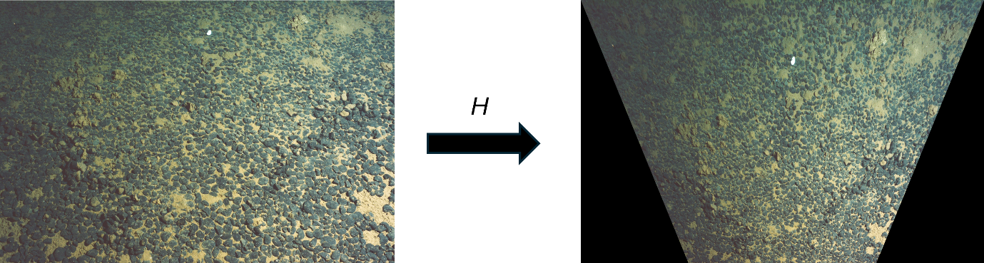
Figure 2. The perspective transformation applied to the original image, based on real-world and pixel coordinates used to compute the homography matrix H (Equation 12). The corrected image uses a real-world scale, with each pixel representing 1 mm.
This transformation can also be applied to any annotations made on the original image, enabling standardized computation of ecological metrics. Orientation of the axes are positive downward for X and to the right for Y, with the origin being the upper-left corner of the image.
Additionally, a regular grid (e.g., 100 mm spacing) can be overlaid on the transformed image (Figure 3). Using the inverse of the homography matrix, the metric grid can be projected into the original pixel coordinate system.
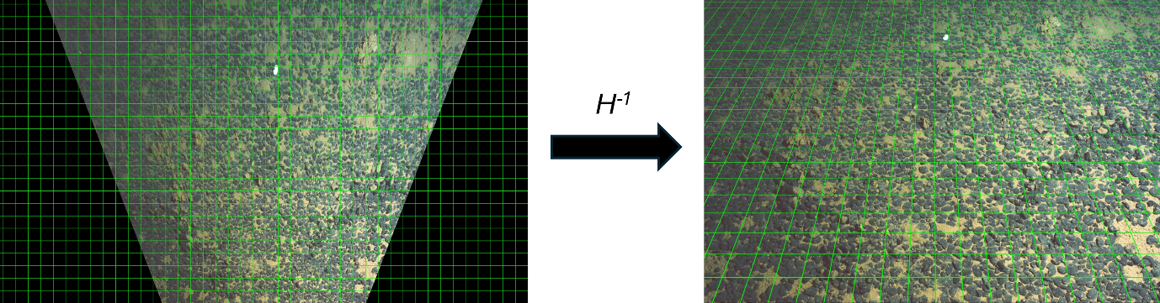
Figure 3. Reversing the transformation using the inverse homography matrix H, enabling overlay of a perspective grid onto the original image.
Image resolution, expressed in mm per pixel, can be mapped over the original image. This can be carried out by applying iteratively the homography matrix to the four corner coordinates of each pixel. The application of the Shoelace formula on the transformed coordinates derives the area covered by that pixel after perspective transformation, in real-world units (mm² per pixel²). A row-wise average of the square root of these values will allow mapping the resolution across the image to visualise the non-linear increase of the resolution ratio as the length of the line-of-sight increases (i.e., the distance from the camera to the point captured by the pixel).
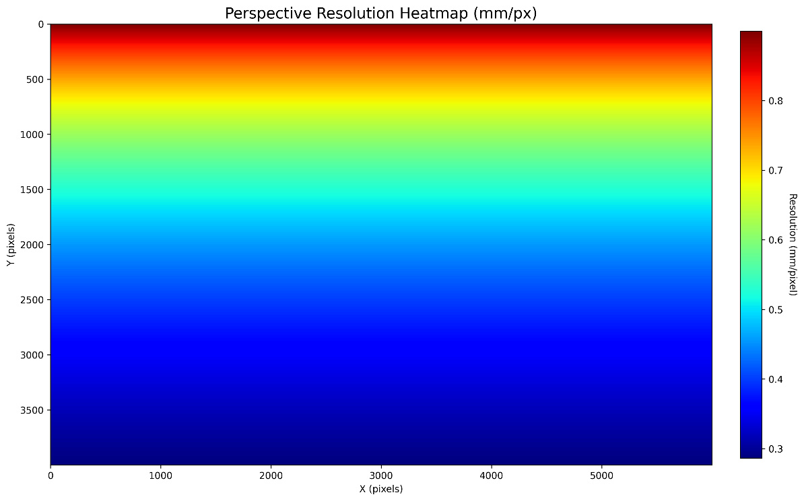
Figure 4. Heatmap of the image resolution, expressed in mm per pixel, allowing to visualise the non-linear change in image resolution due to perspective, from 0.28 to 0.90 mm per pixel. The top edge of the image represents pixel located further away from the camera.

